1)Analog to digital converter (ADC) is a system which transforms analog inputs to digital inputs such as microphone which transforms sound to digital signals or digital camera which transforms light entering the camera to digital signals. Digital to analog converter is doing these things in a reverse order which means it converts digital signals to analog signal, like a speaker or mobile phone. If we have measured the time interval between two successive digital outputs of ADC, sampling rate is 1 over this value.

2) Sample points are coming from analog to digital converter as digital values. When more than one sample points gathered it becomes waveform point which is stored in a memory to monitor in the oscilloscope. So, waveform points are also digital values which is created by sample points.

3) It can be used to capture very fast repeating signals. Because the signals are too fast to obtain the samples, equivalent-time sampling can be used by digital oscilloscope to get enough samples. It cannot get enough information in just one pass so, it fills the record with waveform points in one pass in every repetition.

4) In order to monitor aperiodic signals, we need to use single sequence trigger mode. The display is clean until it reaches its trigger level after that captured waveform is displayed and kept in screen.

5) Looking at the graphs below observation can be made that waveform has distortions in undercompensated and overcompensated graphs. However, display done without any mistakes in those graphs’ values are less accurate.

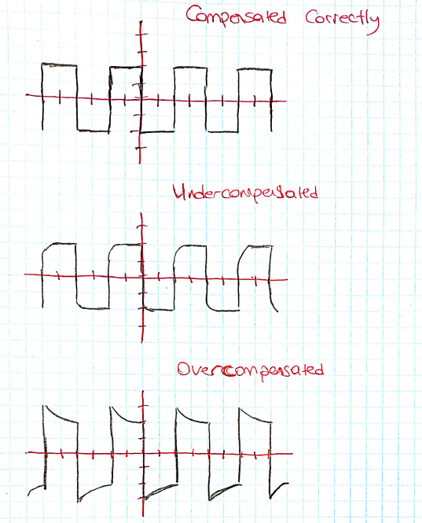

6)

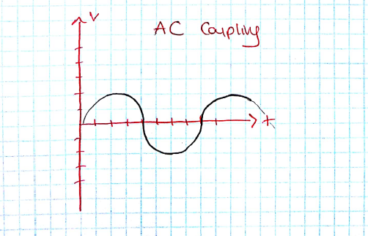

7) Digital scopes continuously operate and store the signals whether trigger level has been reached or not and this is called pretrigger viewing.

8) Because trigger point is 4V and the voltage is not reaching 4V it shows nothing on the screen. In order to avoid this, **a)** voltage value of level control can be decreased or **c)** auto mode can be preferred which is also going to do the same thing by automatically.

Şevki Gavrem Kulkuloğlu

21601793

Section 2